







+91 9313035076, +91 9537651265
info@bkexportsinternational.com www.bkexportsinternational.com
90, Jasodanagar Cross Road, Nr. Canal, Opp. Baroda Express Highway, Amraiwadi, Ahmedabad, Gujarat, India - 380026

Third Party Payment Agreement
DATE :- 04-07-2026

I am Alpesh Bhagwatilal Jain, Director of B K EXPORTS, writing this letter for the Payment Agreement.

This is declared that Exporter name is “B K EXPORTS”. the Importer name is “CMK TRADING COMPANY LIMITED”. Payment of will be Received from “VLC TRADING COMPANY LIMITED”.

Kindly consider this genuine letter of Payment Agreement. You can contact me in case you require any clarification. I am providing my contact details for the same

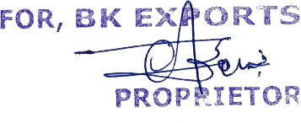 |  | 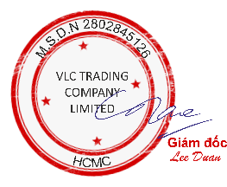
B K EXPORTS | CMK TRADING COMPANY LIMITED | VLC TRADING COMPANY LIMITED

